**DAILY ONLINE ACTIVITIES SUMMARY**

|  |  |  |  |  |  |  |  |  |
| --- | --- | --- | --- | --- | --- | --- | --- | --- |
| **Date:** | **03-06-2020** | | | | | **Name:** | **Shashikant Chavan** | |
| **Sem & Sec** | **8th sem B sec** | | | | | **USN:** | **4AL16CS090** | |
| **Online Test Summary** | | | | | | | | |
| **Subject** | | **-** | | | | | | |
| **Max. Marks** | | **-** | | **Score** | | | **-** | |
| **Certification Course Summary(Internship)** | | | | | | | | |
| **Course** | **Ethical Hacking** | | | | | | | |
| **Certificate Provider** | | | **GreatLearning** | | **Duration** | | | **6 hours** |
| **Coding Challenges** | | | | | | | | |
| **Problem Statement:**  **1) To print the pattern of the following form containing the numbers**  **Sample Input 0**  **2**  **Sample Output 0**  **2 2 2**  **2 1 2**  **2 2 2** | | | | | | | | |
| **Status: completed** | | | | | | | | |
| **Uploaded the report in Github** | | | | | **yes** | | | |
| **If yes Repository name** | | | | | **alvas-education-foundation/Shashikant_chavan** | | | |
| **Uploaded the report in slack** | | | | | **yes** | | | |

Online Test Details: (Attach the snapshot and briefly write the report for the same)

Certification Course Details: (Attach the snapshot and briefly write the report for the same)

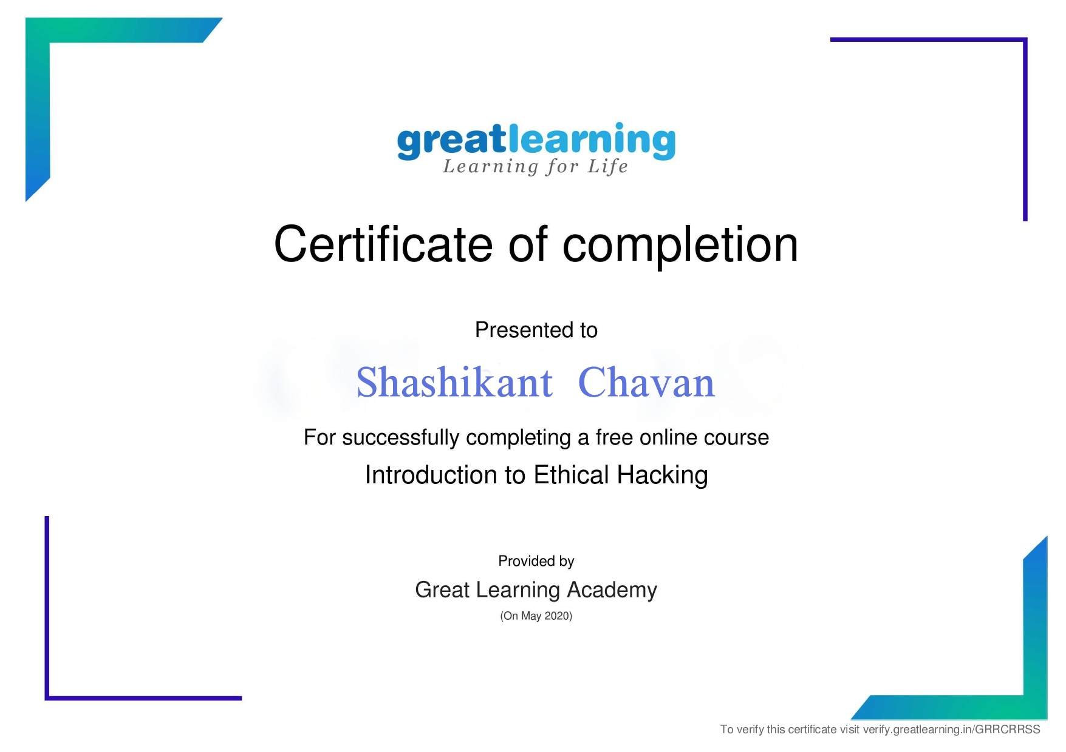

Coding Challenges Details: (Attach the snapshot and briefly write the report for the same)

Coding was given n it was uploaded for github and slack

PROGRAM1

#include <stdio.h>

int main()

{

int n;

scanf("%d", &n);

int len = n*2 - 1;

for(int i=0;i<len;i++){

for(int j=0;j<len;j++){

int min = i < j ? i : j;

min = min < len-i ? min : len-i-1;

min = min < len-j-1 ? min : len-j-1;

printf("%d ", n-min);

}

printf("\n");

}

return 0;

}

|  |
| --- |
|  |